The screenshots below show the dependencies between the CDS Views.

**Consignment Visibility Insights – KPI**

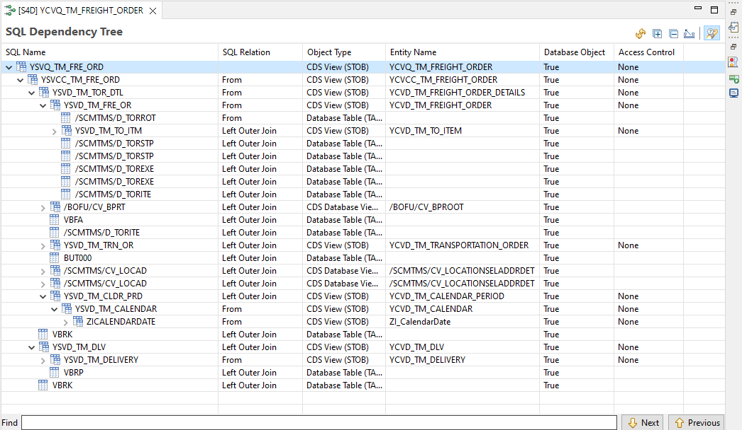

**Freight Agreements getting Invalid – KPI**

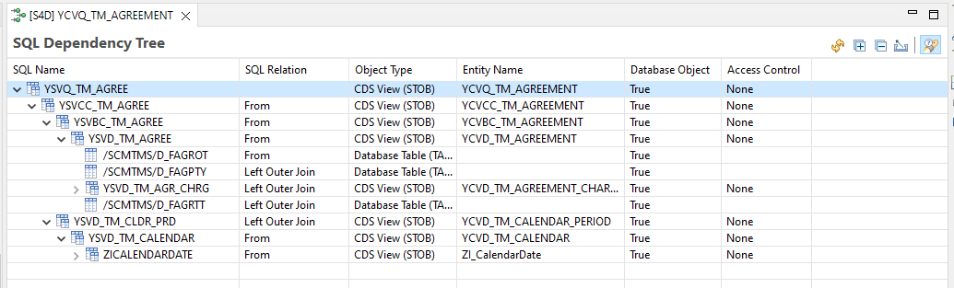

**Top/Bottom 10 Carriers – KPI**

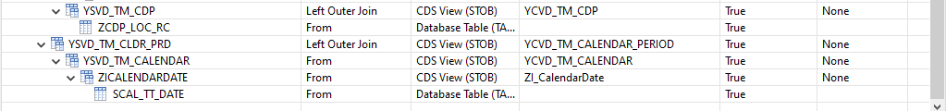

**Outbound Transportation Cost – KPI**

**Total Cost – KPI**



